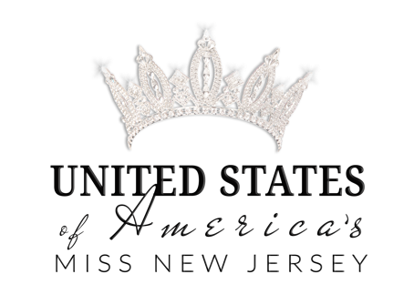

Dear Potential Sponsor,

I am (insert name here), your reigning UNITED STATES OF AMERICA’S (insert local title here). I will be representing ( insert your town/county) at the State competition for the title of UNITED STATES OF AMERICA’S (insert division) PENNSYLVANIA! I am honored and excited to a representative for our great state in the annual competition, held in October!

UNITED STATES of America PAGEANTS are designed to encourage all women to strive to ACHIEVE their hopes, dreams, goals, and aspirations, while making them feel CONFIDENT and BEAUTIFUL inside and out! We believe the true definition of beauty is "The unique set of combinations that make you, You!" UNITED STATES of America PAGEANTS motto is to EMPOWER Women, INSPIRE others, & UPLIFT everyone! focus on women empowerment, promoting positive self-image and advocating a platform of community service, which allows every contestant to rise by lifting others. But more importantly we are an elite sisterhood that gives support and encouragement to inspire each delegate to be the best version of herself!

“There is no tool for development, more effective than the empowerment of women”-Kofi Annan
.
There can be many costs associated in preparing for and taking part of a competition of this magnitude. I am asking for your support to help me realize my dream of becoming the next UNITED STATES OF AMERICA’S (insert division) PENNSYLVANIA.

YOU can play an integral part in helping me realize my dream of becoming the next UNITED STATES OF AMERICA’S (insert division) PENNSYLVANIA by becoming my OFFICIAL sponsor! I will be featured in a full-page advertisement in the program book at the state competition. I would greatly appreciate your sponsorship and support and would like to highlight your business on my official page that will be seen by people from all over the state!

There is no donation too big or too small. Any amount is greatly appreciated. To receive personal thanks on the state advertisement page is a minimum of $50 donation. You could also place your own Ad in the program book: $299 for a full page, $150 for half a page!

Please send donations via PayPal to ( INSERT YOUR PAYPAL ACCOUNT) and email your high resolution logo as a 300dpi PNG file to (INSERT YOUR EMAIL)

Let’s bring home the State title to (insert county/ Town)!

Thank you for all your support,

